**Q2. Describe the categorisation of operators in JavaScript based on their functionality. Provide examples for**

**each category.**

There are 7 categories of operators in javascript:

* 1. Arithmetic operators
  2. Assignment operators
  3. Comparison operators
  4. Logical operators
  5. Ternary operators
  6. The typeOf operators
  7. Bitwise operators

1. Arithmetic operators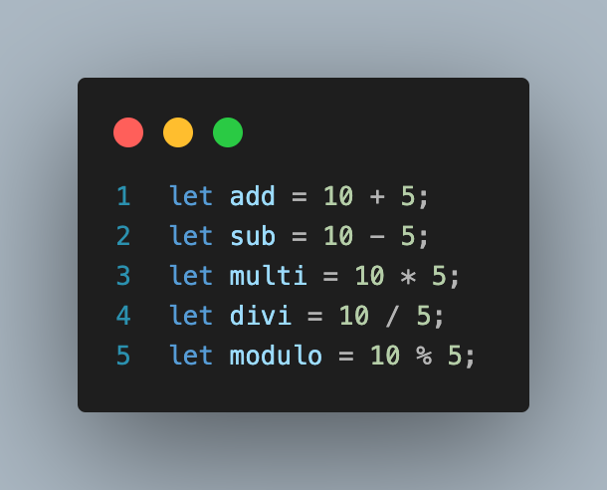

2. Assignment operators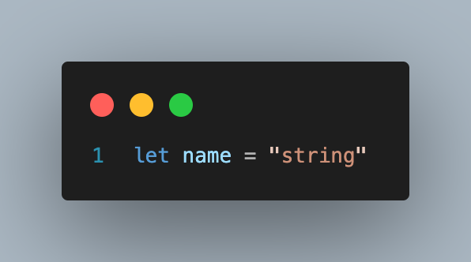

3. Comparison operators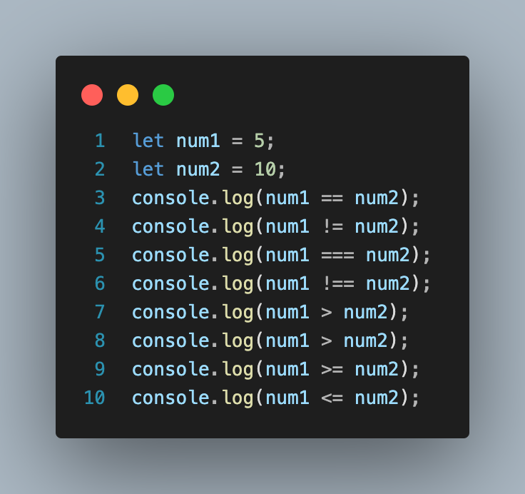

4. Logical operators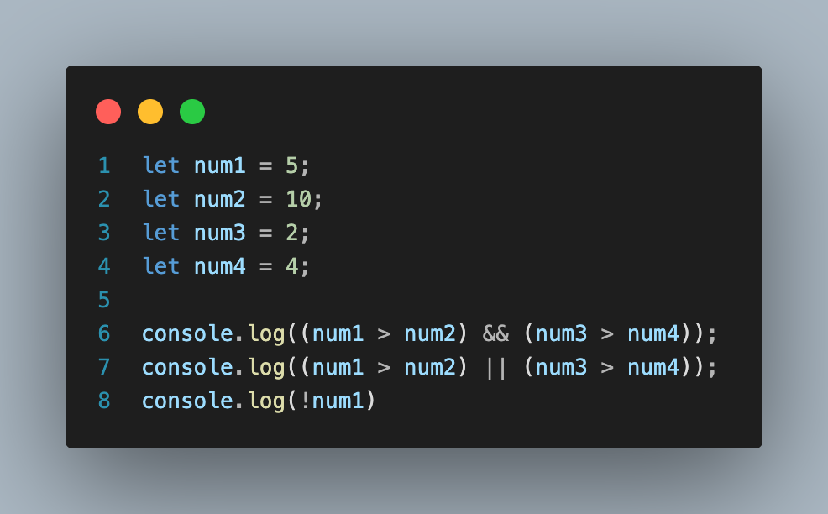

5.Ternary operators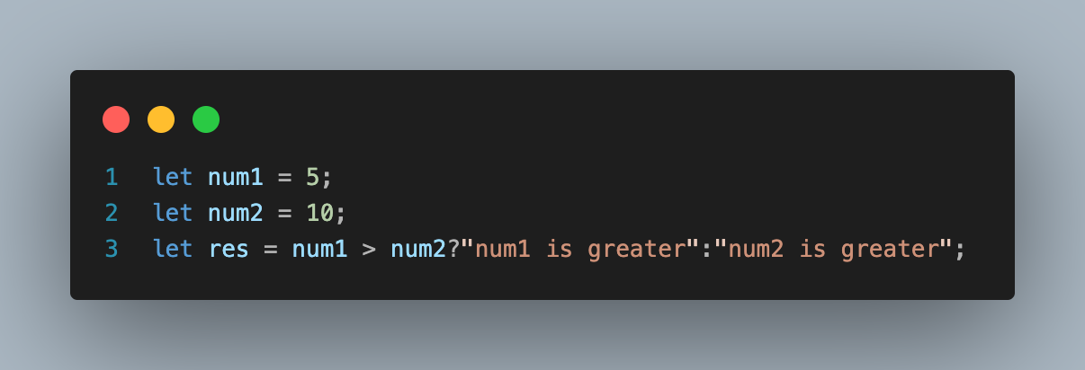

6.Typeof operators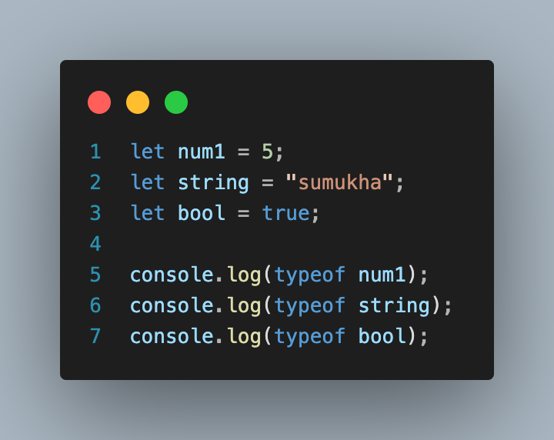

7. Bitwise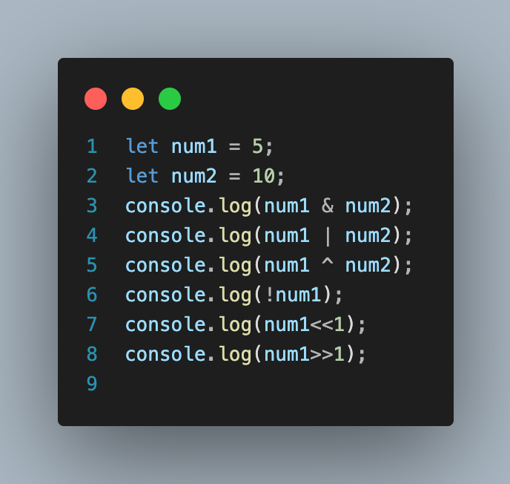 operators